Police Report May 2026

We received a total of 334 calls this month and of these calls 85 crimes were recorded which are broken down into offence groups below. For ease of comparison I’ve included the same period last year:

May 2026 – Total 85

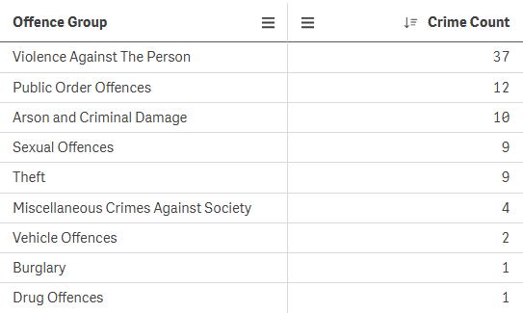

May 2025 – Total 81
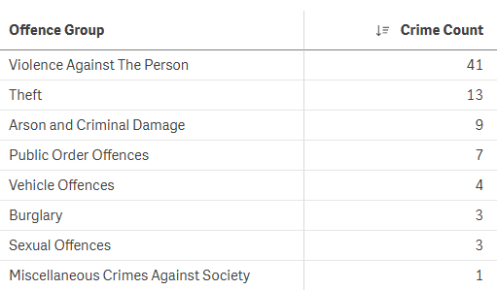

The crime figures have remained steady this month compared to this time last year with no unexpected spikes or trends in any crime type. Once again, our non-crime call volume has risen producing additional demand for police even when crime levels have not increased.

With the significantly warmer weather that we have enjoyed it’s common for windows and doors to be left open. We would remind residents if they are leaving the house that these are secured before going out, particularly on the ground floor as this could prove tempting for an opportunist thief.

I would like to take the opportunity to thank Wellington Town Council for their swift response in managing the eviction of the recent unauthorised encampment in Hoyles Road. In a combined effort, bailiffs in partnership with my team and patrol colleagues from Taunton ensured the successful departure of all occupants from the land. Given that many encampments in other towns remain in situ for significantly longer, this was a prompt resolution for all concerned. The Open Spaces team then followed up with an equally swift response to clear the field and re-secure the entry point. We will continue to work in partnership with the Town Council to review any susceptible open spaces and provide advice on target-hardening measures where appropriate.

A trend we are seeing increasingly more is the use of social media to inform other members of the community about incidents that have recently happened. I fully agree that this is an efficient way of raising awareness and I would always encourage the sharing of information amongst community groups on these platforms.
In certain circumstances however, it can hamper a police investigation if something is posted on social media first and then not reported to the Police until much later, if at all. In a time-critical situation for example, we would stand a much better chance of locating a suspect or vehicle if the matter is reported to us first whilst they might still be in the vicinity. We cannot routinely monitor social media pages/groups so unfortunately this may result in missed opportunities if we have not been made aware at the time.

Last week we took part in a national initiative called Operation Sceptre which is aimed at reducing knife crime. We do not see anywhere near the levels of knife crime that some of the larger towns suffer, but it remains important that education and awareness is spread as widely as possible so that any temptation to carry a knife is diminished. We continue to work with retailers to monitor sales and displays and I would encourage parents to maintain a frequent audit of knives within the household which might be accessible. There is also a knife amnesty bin outside the Police Station where any found or unwanted knives can be safely discarded.

If anyone has any questions or enquiries they wish to make with the team, the enquiry office at Wellington Police Station is open from 10am – 2pm on Mondays, Tuesdays, Thursdays and Fridays. We can be contacted via the Avon & Somerset Police website or by calling 101. Alternatively, feel free to stop any one of us whilst we’re out on patrol and we’ll always be happy to speak with you.

Jon O’Connor
Neighbourhood Sergeant for Wellington

